**SMART ELECTRICITY METER**

Navanisha S1, Nithya Shree VS 2, PR Shashank 3 Pavan L 4

1 [navanishagowda2004@gmail.com](mailto:navanishagowda2004@gmail.com) [,](mailto:manoj998620@gamil.com) 2 [nithyashree242003@gmail.com](mailto:nithyashree242003@gmail.com) ,

[3shashanksurya2003@gmail.com](mailto:3shashanksurya2003@gmail.com) 4[pavanl.securemail@gmail.com](mailto:pavanl.securemail@gmail.com)

**Abstract:**

This paper explores the transformative impact of smart metering technology on energy management. Smart meters, equipped with real-time monitoring and two-way communication capabilities, empower consumers and utilities to optimize energy usage. Through enhanced accuracy and proactive identification of inefficiencies, smart metering fosters energy conservation and supports renewable integration. Despite challenges, smart metering emerges as a cornerstone for building a sustainable energy future, calling for accelerated adoption and integration into global energy systems.

**Keywords- Keywords: Current sensor, Voltage sensor , Arduino ESP32, LED**

# Introduction

In this project, we will build an IoT-based Smart Electricity Energy Meter using ESP32 and the newly updated Blynk 2.0 application. We have previously built an [IoT DC Energy Meter](https://how2electronics.com/iot-dc-energy-meter-using-esp8266-blynk-36v-30a/), [GSM Prepaid Energy Meter](https://how2electronics.com/gsm-based-prepaid-electricity-energy-meter-using-arduino/) and also an IoT [Energy Meter using ESP32](https://how2electronics.com/iot-based-electricity-energy-meter-using-esp32-blynk/) using the old Blynk Application, but with the recent upgrade of the Blynk platform, it was necessary to upgrade our Energy Meter project as well. Our aim is to automate the process of monitoring electricity consumption and make it a more streamlined experience.

Traditionally, monitoring electricity consumption involves manual meter readings, which can be time-consuming and inconvenient. The Internet of Things provides a solution by automating remote data collection, thereby saving time and money. The concept of a Smart Energy Meter has gained significant popularity worldwide in recent years, making this an excellent opportunity to build our own IoT-based electricity energy meter.

We will create an IoT-based Smart Electricity Energy Meter using ESP32 and the updated Blynk 2.0 application. By using the best current sensor (SCT-013) and voltage sensor (ZMPT101B), we can measure voltage, current, power, and total energy consumed in kWh. The readings will be sent to the Blynk 2.0 application and displayed on a dashboard accessible from any location. In case of power outages, the energy meter data will be stored in ESP32’s EEPROM, ensuring continuous readings. Let’s start our project to automate electricity consumption monitoring.

# Proposed Architecture

The VCC & GND pins of both the SCT-013 Current Sensor and ZMPT101B Voltage Sensor are connected to the Vin & GND of ESP32, which is a 5V supply. The output analog pin of the ZMPT101B Voltage Sensor is connected to the GPIO35 of ESP32 and the output analog pin of the SCT-013 Current Sensor is connected to the GPIO34 of ESP32. Additionally, two 10K resistors and a single 100-ohm resistor, along with a 10uF capacitor, are required to complete the circuit.To measure the current and voltage, the AC wires must be connected to the input AC Terminal of the Voltage Sensor. For the Current Sensor, only a single live or neutral wire needs to be inserted inside the clip part.The ESP32/SCT-013/ZMPT101B Energy Meter data can be monitored on the Blynk Application without connecting the LCD display.

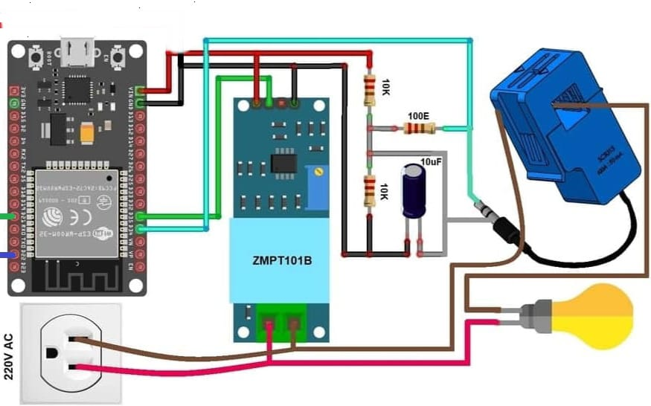

**Figure 2.1 Architecture**

# METHODOLOGY

**1. Requirements Gathering:**

**-** Identify the key requirements for the smart electricity meter project, including data collection frequency, communication protocols, and compatibility with existing infrastructure.

**2. Hardware Selection:**

**-** Choose appropriate hardware components for the smart electricity meter, considering factors such as accuracy, reliability, and cost-effectiveness. This may involve selecting sensors, microcontrollers, communication modules, and power supplies**.**

**3. Software Development:**

**-** Develop firmware or software for the smart electricity meter to handle data acquisition, processing, and communication tasks. This includes programming logic for real-time monitoring, data storage, and communication with utility providers or end-users.

**4. Integration with Communication Networks:**

**-** Integrate the smart electricity meter with communication networks such as Wi-Fi, cellular, or LoRaWAN to facilitate data transmission to central servers or cloud platforms. Ensure compatibility with existing network infrastructure and security protocols.

**5. Calibration and Testing:**

**-** Calibrate the smart electricity meter to ensure accurate measurement of energy consumption. Conduct rigorous testing under various operating conditions to validate the meter's performance and reliability.

**6. Deployment and Installation:**

**-** Install the smart electricity meters at target locations, such as residential or commercial buildings, following standard installation procedures. Ensure proper wiring, mounting, and configuration to enable seamless operation.

**7. Monitoring and Maintenance:**

**-** Implement a monitoring and maintenance plan to ensure ongoing performance and reliability of the smart electricity meters. This may involve remote monitoring of meter health, regular firmware updates, and proactive maintenance to address any issues promptly.

**4. Hardware Implementation Results:**

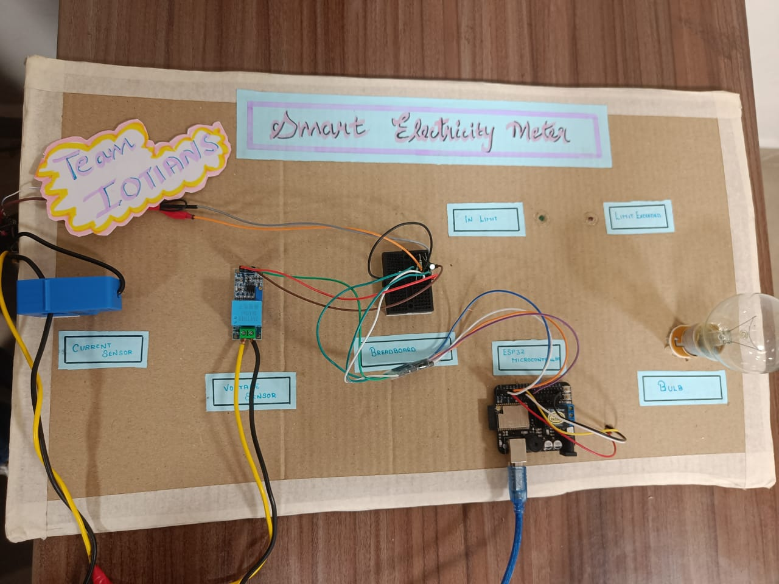

**5. CONCLUSION**

Smart electricity meters represent a transformative leap in energy management. Their real-time monitoring and two-way communication empower consumers and utilities alike to optimize energy usage efficiently. By fostering a culture of energy consciousness, these meters drive conservation efforts while aiding grid management and reliability. Despite challenges like privacy and cybersecurity, collaboration can overcome them. As technology advances, smart meters will evolve, offering even more sophisticated solutions for a sustainable energy future.

**6. REFERENCES**

* Preethi, V., and G. Harish. "Design and implementation of smart energy meter." In *2016 International Conference on Inventive Computation Technologies (ICICT)*, vol. 1, pp. 1-5. IEEE, 2016.
* Arif, A., Al-Hussain, M., Al-Mutairi, N., Al-Ammar, E., Khan, Y. and Malik, N., 2013, March. Experimental study and design of smart energy meter for the smart grid. In *2013 international renewable and sustainable energy conference (IRSEC)* (pp. 515-520). IEEE.
* Sun, Q., Li, H., Ma, Z., Wang, C., Campillo, J., Zhang, Q., Wallin, F. and Guo, J., 2015. A comprehensive review of smart energy meters in intelligent energy networks. *IEEE Internet of Things Journal*, *3*(4), pp.464-479.
* Sahani, B., Ravi, T., Tamboli, A. and Pisal, R., 2017. IoT based smart energy meter. *International Research Journal of Engineering and Technology (IRJET)*, *4*(04), pp.96-102.
* Avancini, D.B., Rodrigues, J.J., Rabêlo, R.A., Das, A.K., Kozlov, S. and Solic, P., 2021. A new IoT‐based smart energy meter for smart grids. *International Journal of Energy Research*, *45*(1), pp.189-202.
* Barman, B.K., Yadav, S.N., Kumar, S. and Gope, S., 2018, June. IOT based smart energy meter for efficient energy utilization in smart grid. In *2018 2nd international conference on power, energy and environment: towards smart technology (ICEPE)* (pp. 1-5). IEEE.
* Prathik, M., Anitha, K. and Anitha, V., 2018, February. Smart energy meter surveillance using IoT. In *2018 International conference on power, energy, control and transmission systems (ICPECTS)* (pp. 186-189). IEEE.
* Chaudhari, S., Rathod, P., Shaikh, A., Vora, D. and Ahir, J., 2017, May. Smart energy meter using Arduino and GSM. In *2017 International Conference on Trends in Electronics and Informatics (ICEI)* (pp. 598-601). IEEE.